RetainIQ Content
Landing
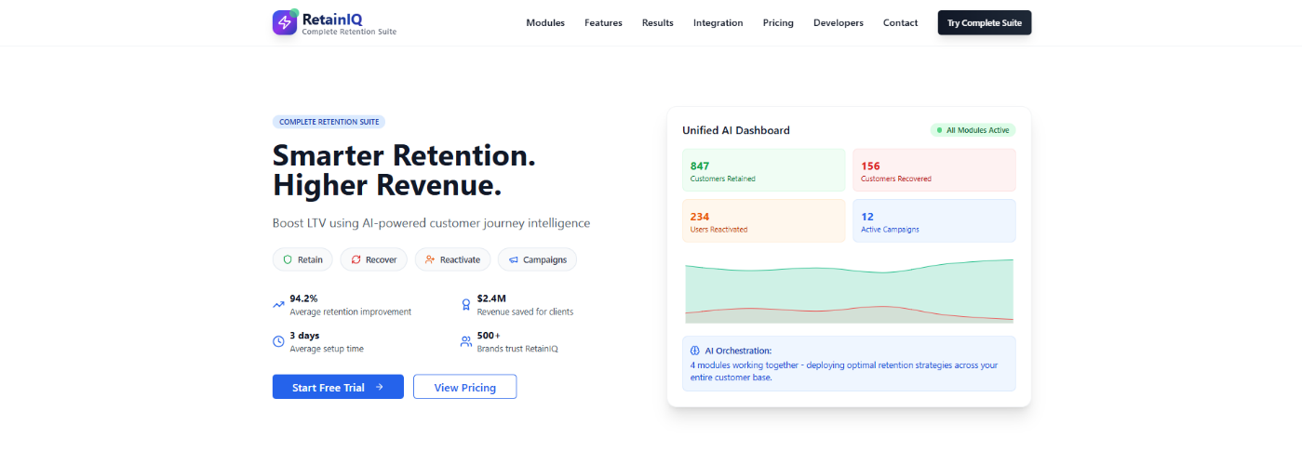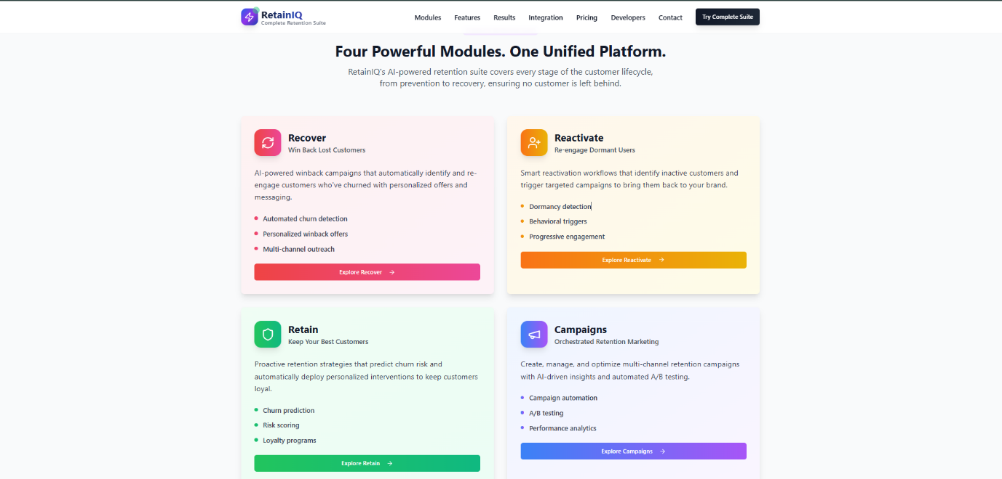
Landing page of RetainIQ contains all the information about what to expect once inside the web application. It contains 4 modules-> Recover, Reactivate, Retain and Campaigns.
Dashboard
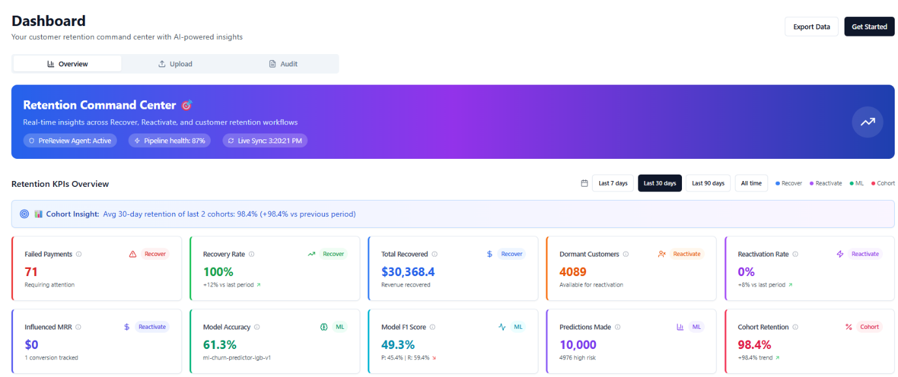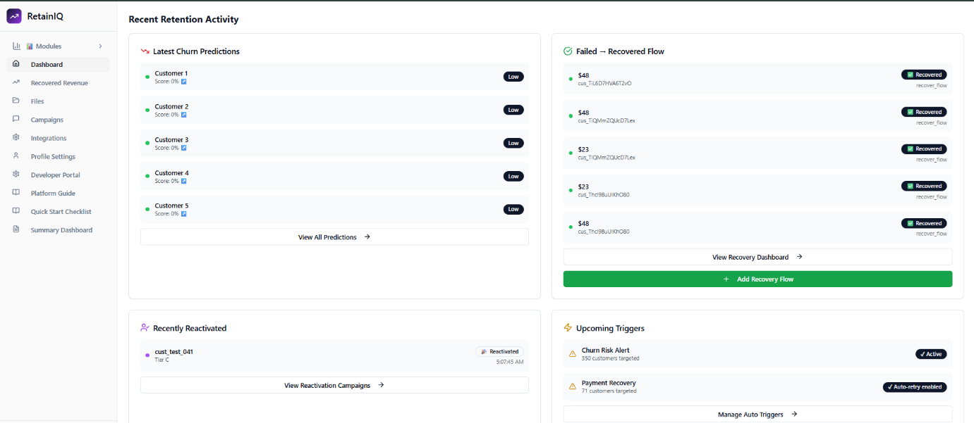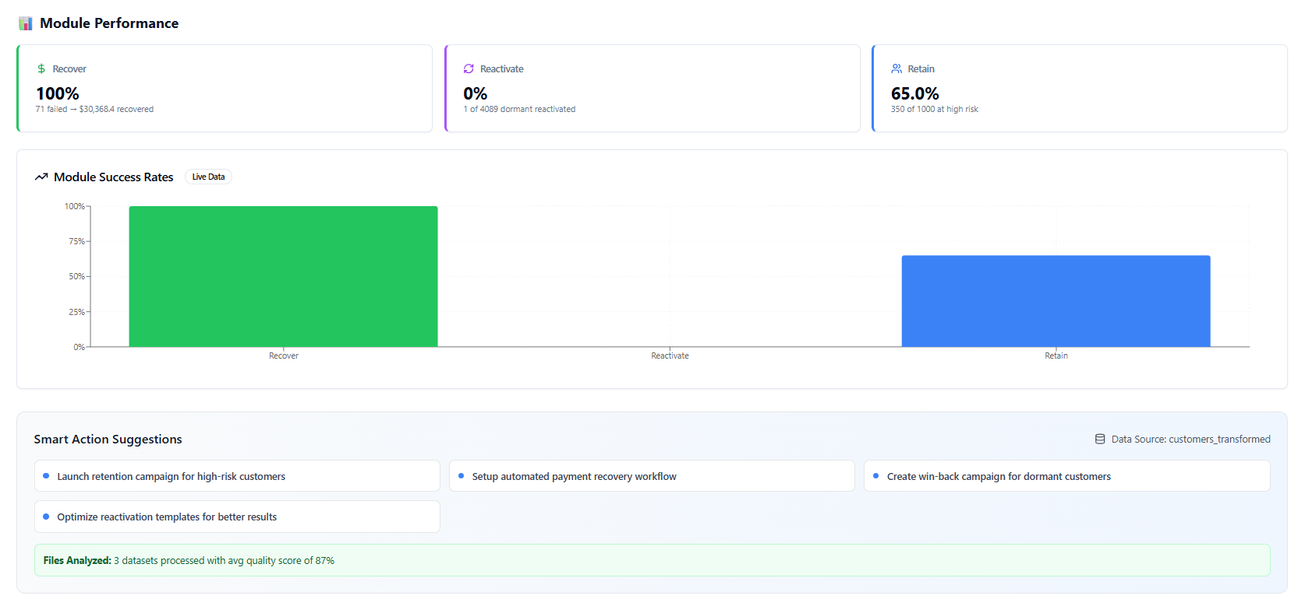
Dynamic dashboard, that summarises all the modules working in proper sync. Shows the Machine learning model (lightBGM) with all the predictions made. Moreover, you can see the recent recoveries and reactivations, with a comparison of all the modules. Lastly, there is a smart action suggestion system powered by GPT, which observes the dashboard and suggest based on it.
Recover Module
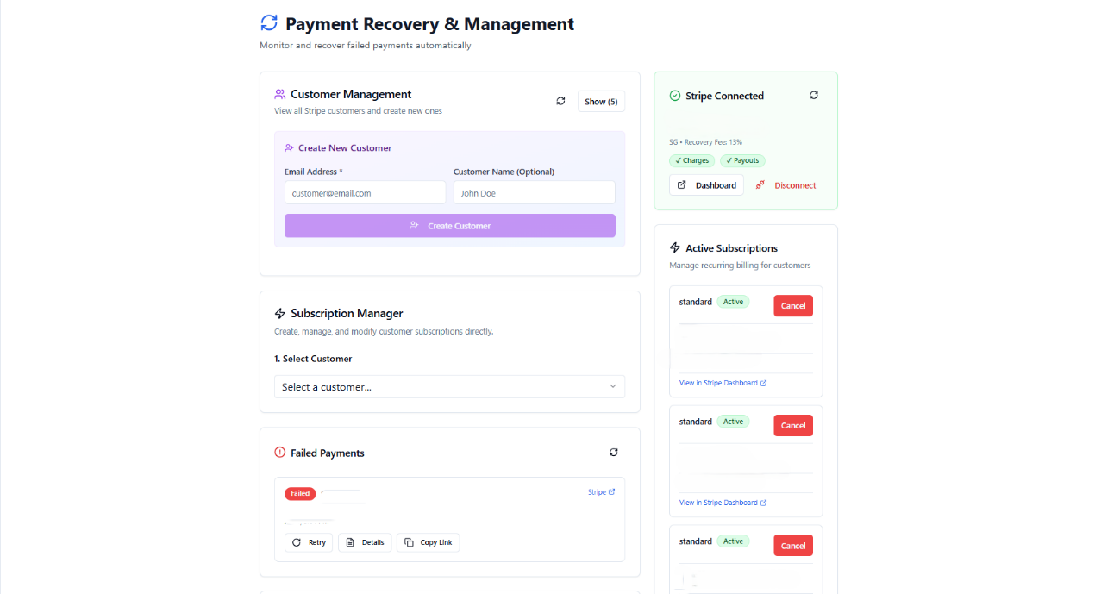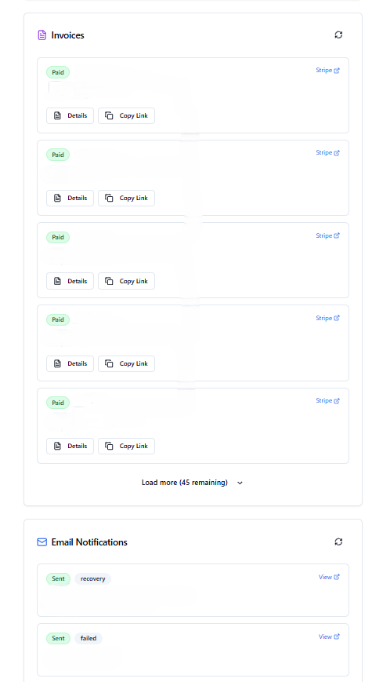
Recover is a highly technical module that works with Stripe + Pipedream (automation). Use of stripe express that makes use of connected accounts for a platform fee. The failed payment is routed via the web application, and if there is a failed payment then it will show up and automatically a fee link will be emailed to the customer. Once they pay, it will be recovered and the email will be sent as a confirmation. This will also be shown in the UI as well.
Stripe is handled by stripe itself, and no sensitive information is saved in the database.
Reactivate Module
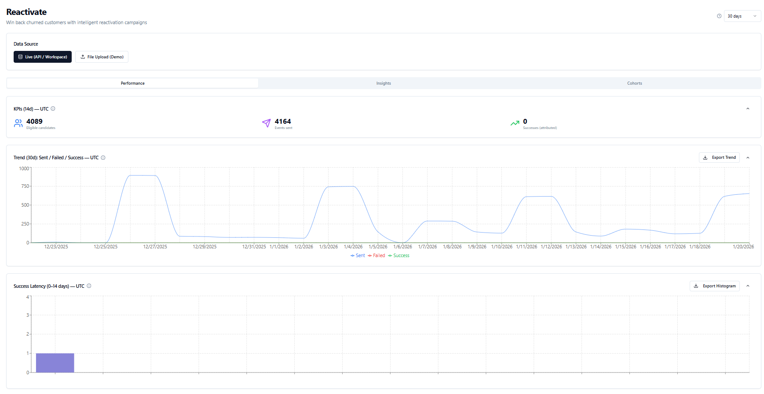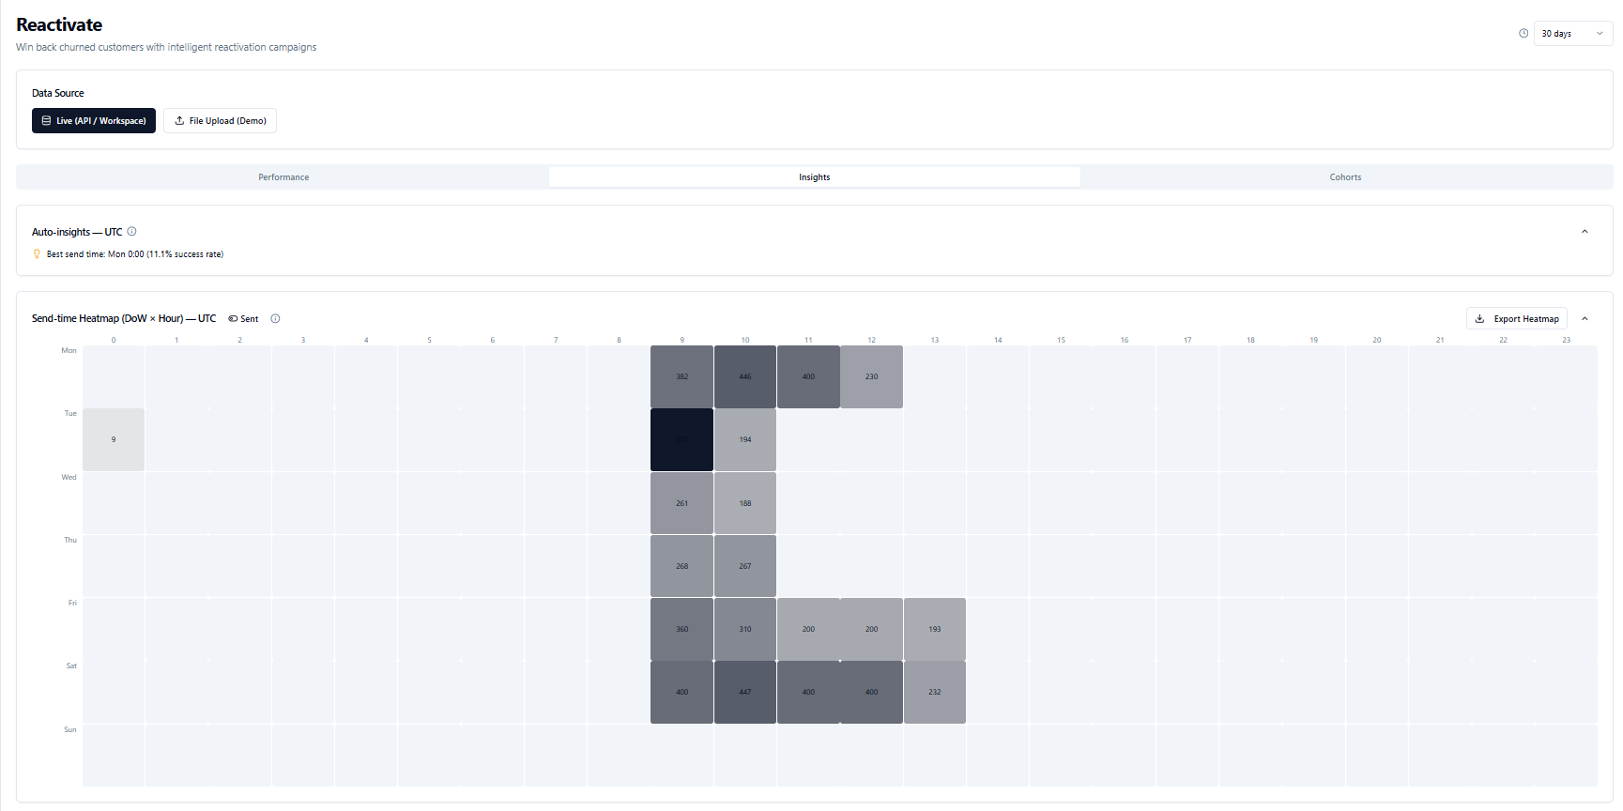
Reactivate Module works after adding the customers after running through the prediction pipeline. An activity mechanism calculates which customer is dormant. Once confirmed, a cron job runs and queues them up for email sending via Pipedream. Once queued another cron job runs the edge function and triggers the email send workflow. A reactivation link is emailed to the customer and if they make a payment after clicking the link it will be marked as reactivated.
Retain Module
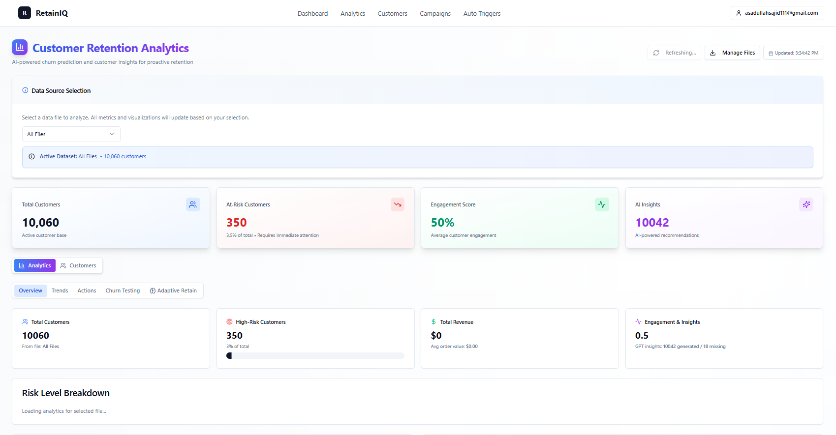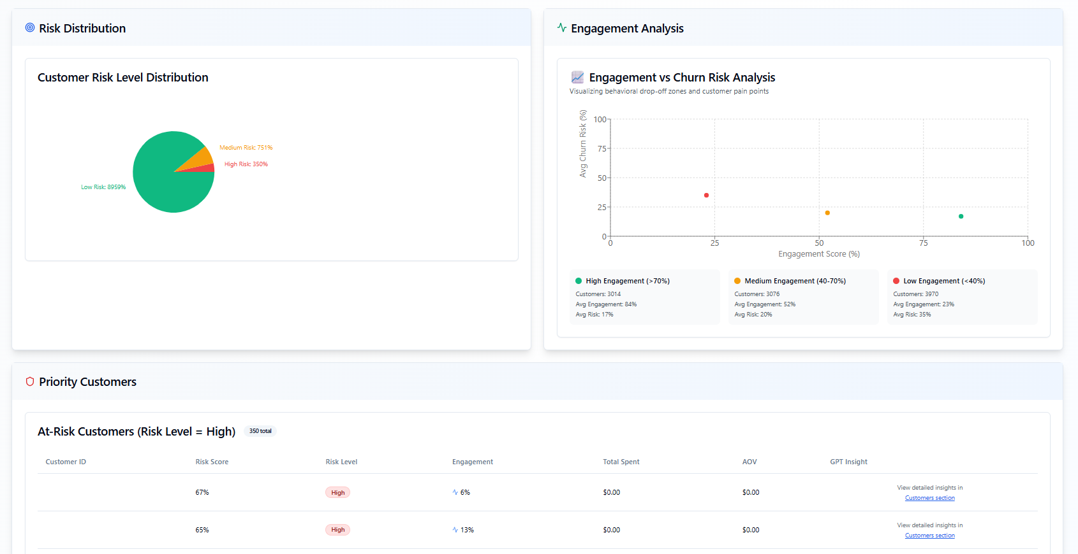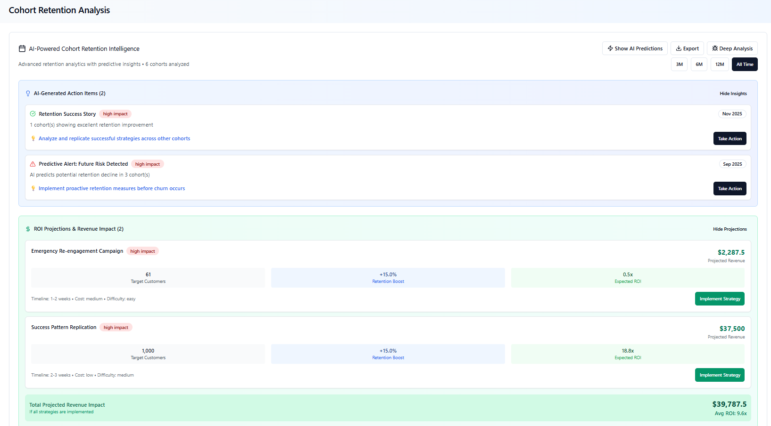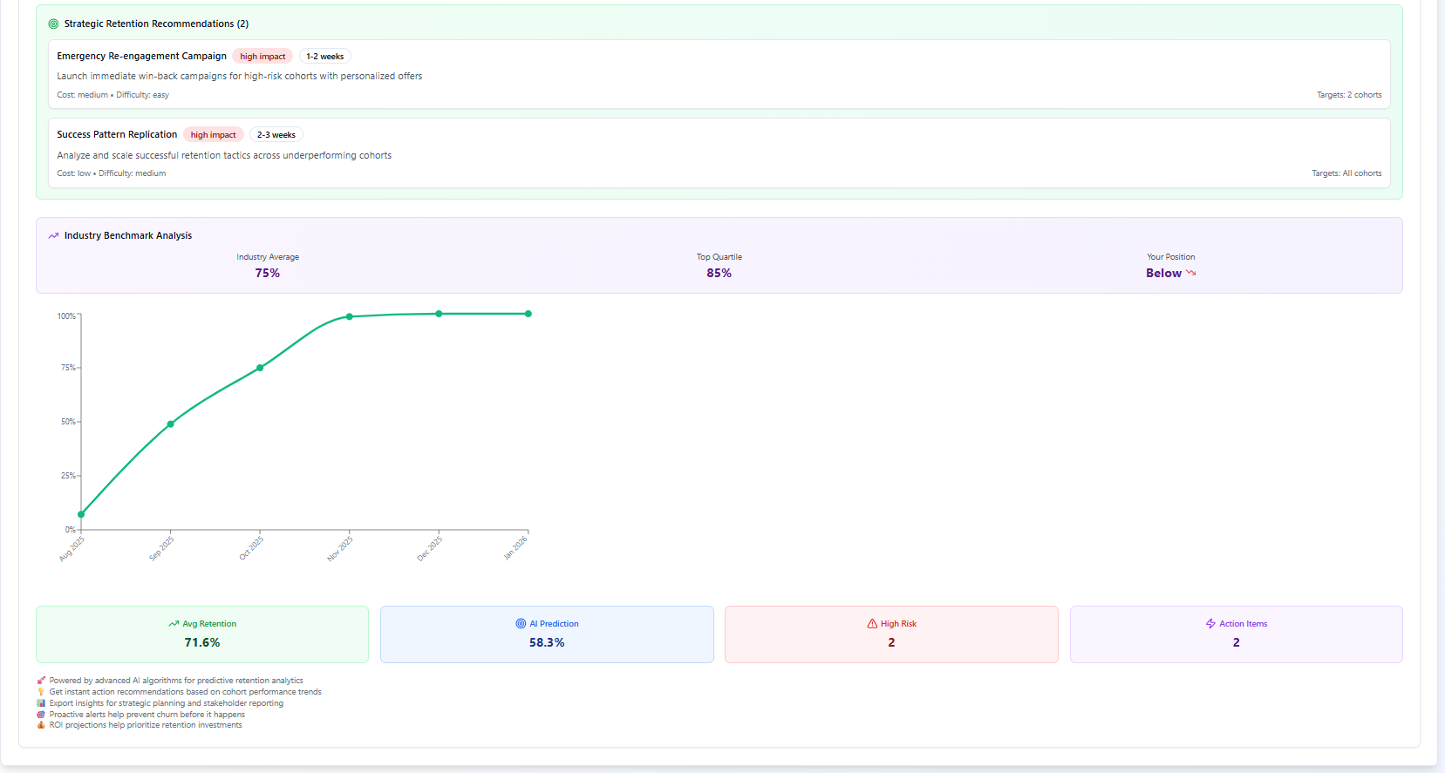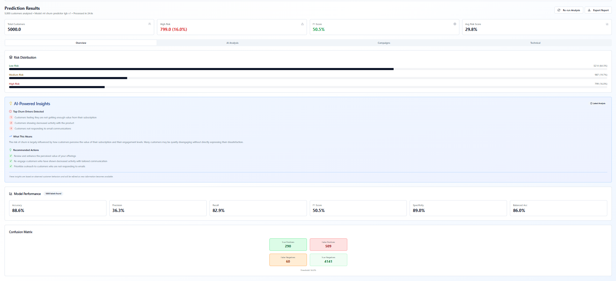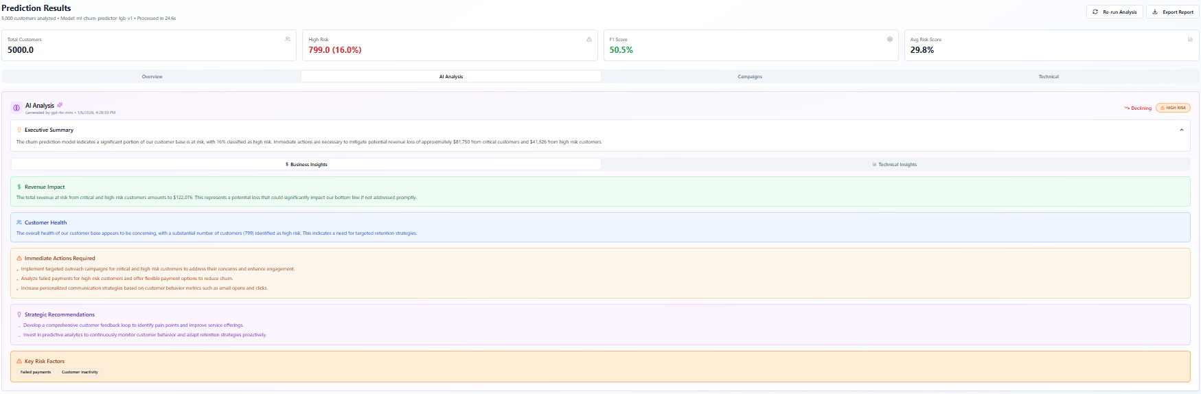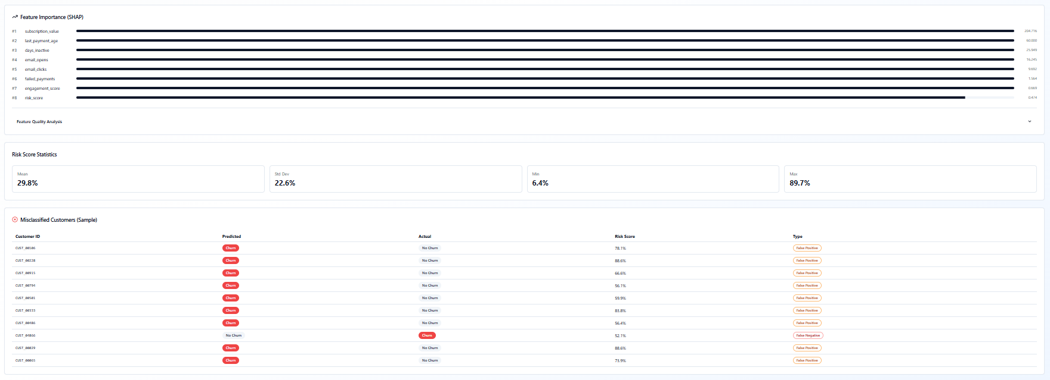

Retain module is the heart of RetainIQ, it uses a prediction system as well as a churn prediction system where we use the Machine Learning model (lightBGM) trained on telcomIBM dataset, and predict the customers trend based on it. The users can use the KPIs accordingly to make suggestions based on them. There is a variety of metrics including cohort analysis, GPT based insights (technical + business). Moreover, you can also choose each file individually and check the analysis separately, and see which feature dominates the most.
Campaigns
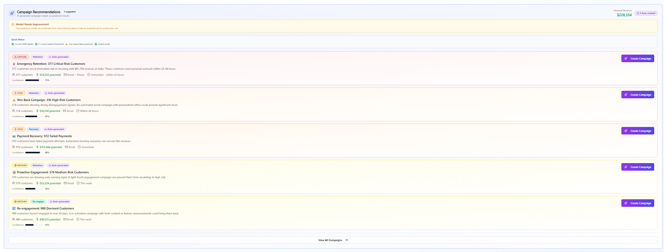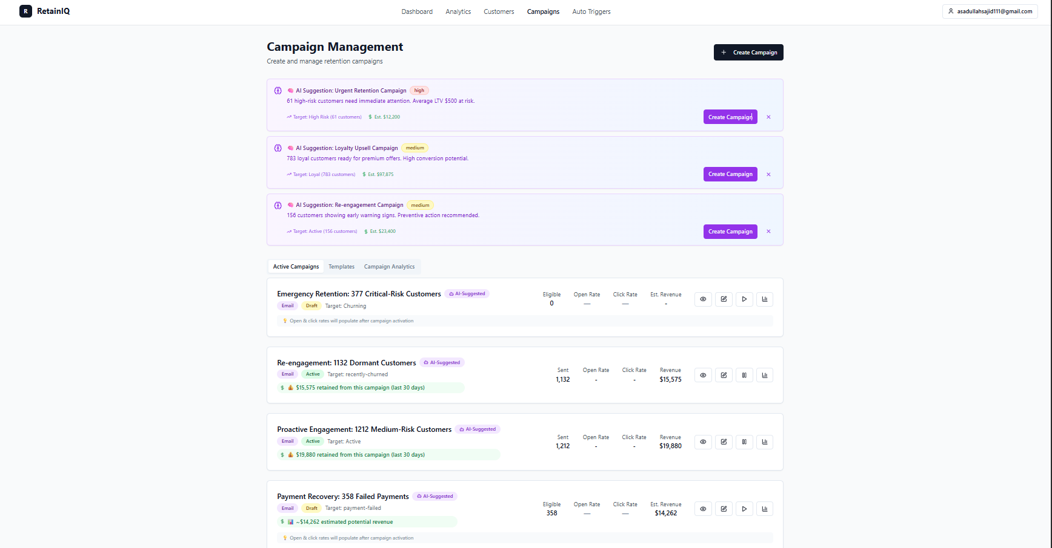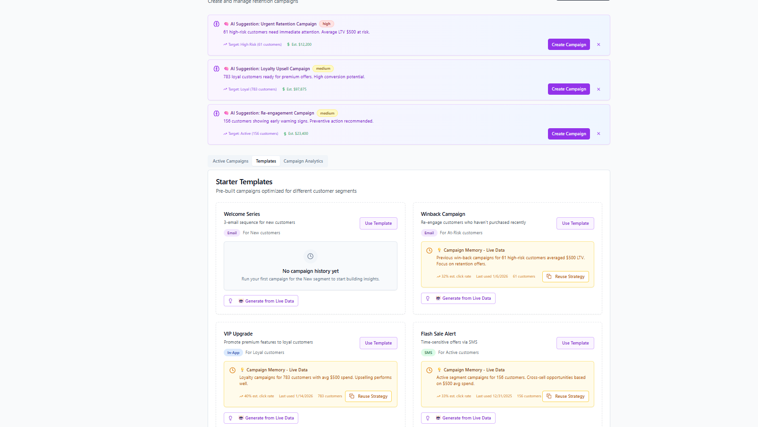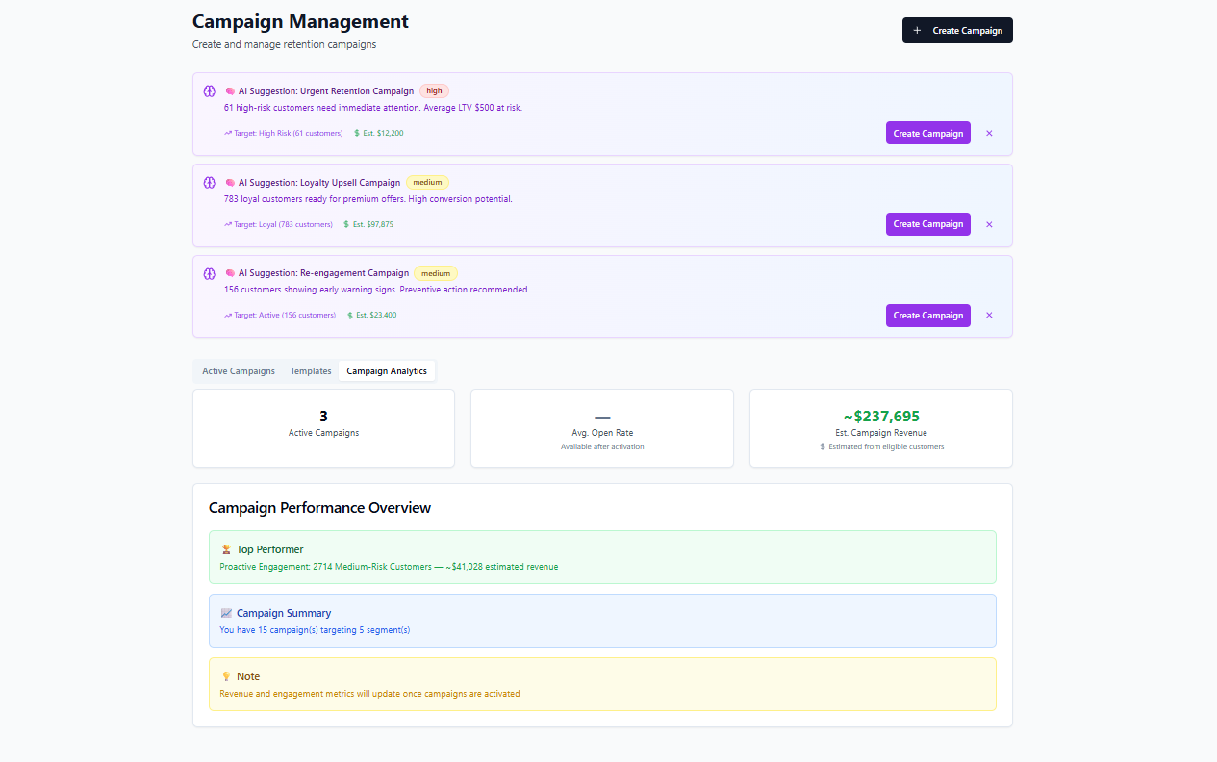
Once the churn test and prediction is made, the campaigns is the final step. You can choose the campaigns that are generated by GPT, which are targeted specifically for each customer type or create your own and send that to the customer via a Zapier workflow for mailchimp or Gmail directly. Whatsapp is an option too, which is a very powerful tool for churn retention.

